**CHEG401 - Chemical Process Dynamics and Control**

**Lab 5 - Model-Based and Digital Control**

Li Pei Soh

Linh Nguyen

Khai Khee Kho

Abdul Fayeed Abdul Kadir

November 18th, 2021

College of Engineering, Department of Chemical and Biomolecular Engineering

University of Delaware

Newark, Delaware 19711

**5.1 Part I: Control of a Pilot Scale Twin-Screw Extruder**

1. **Direct synthesis controller design**

With a closed-loop system , we want to design a controller to obtain closed loop behavior as q(s)=, . To design controller for manipulating the Die Pressure,y1 with feed rate,u1 with transfer function gc1, we use because it relates to . We use the reference trajectorybecause it has no zero and 1 pole which is the same as g11. To design controller for manipulating the Screw speed,u2 to control Drive Torque, y2 with transfer function gc1, we use because it relates to and we use for modeling an inverse response reference trajectories; we select this reference trajectory because it has 1 zero and 2 poles which is the same as g22.

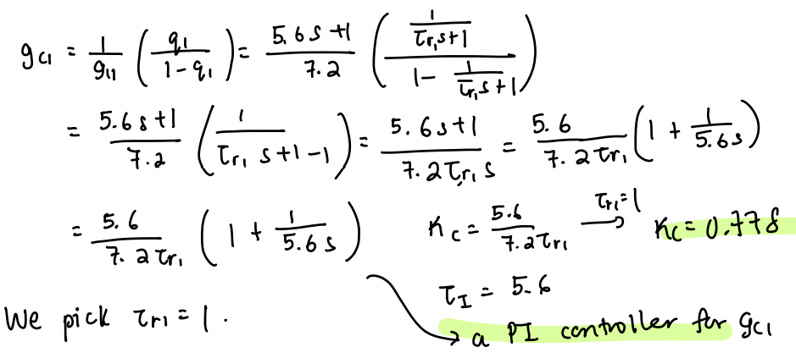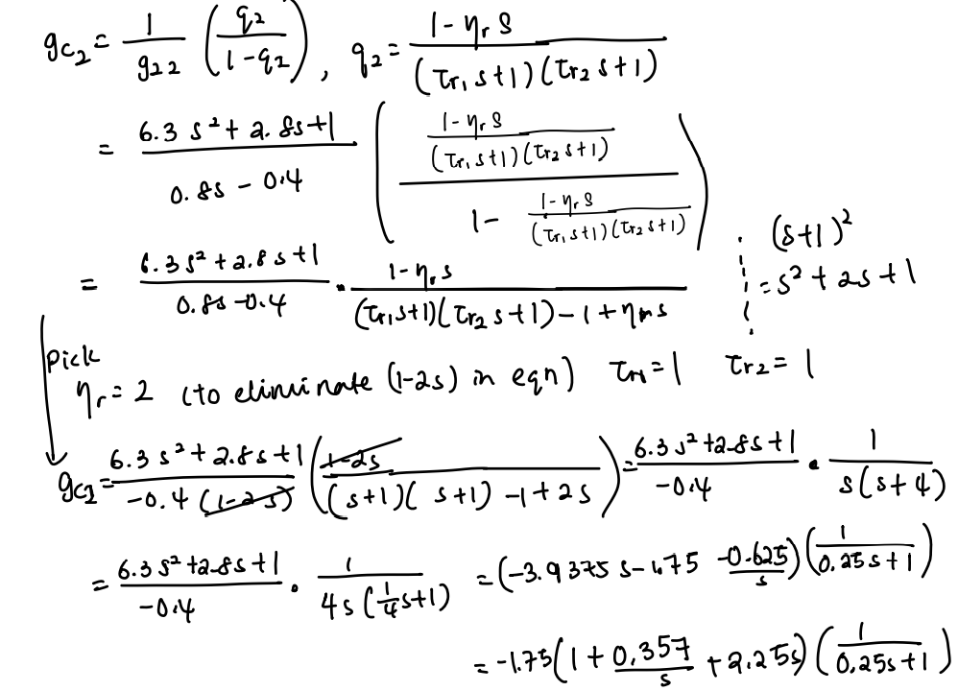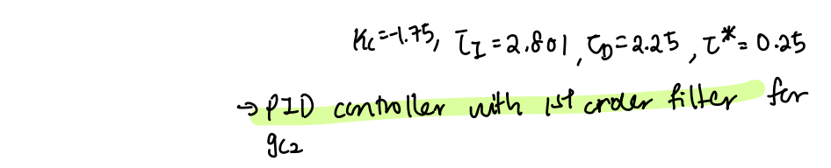

1. **SIMULINK implementation**

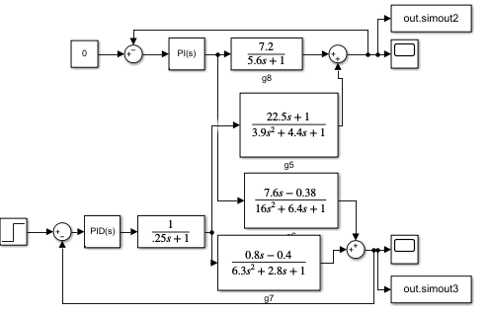

**Figure 1.** SIMULINK setup for Pilot Scale Twin-screw Extruder (, first simulation).

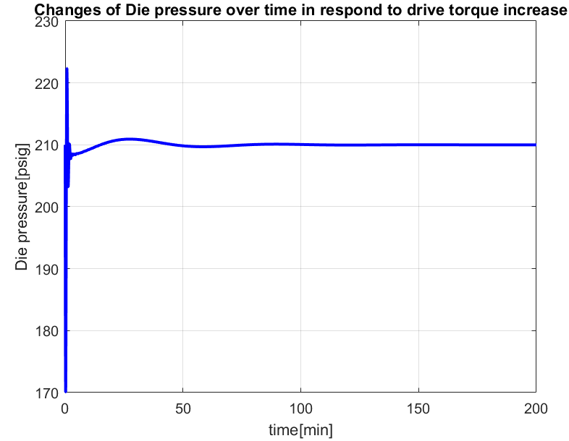

**Figure 2.** Response of Die pressure to increase in drive torque with controller designed (, initial simulation)

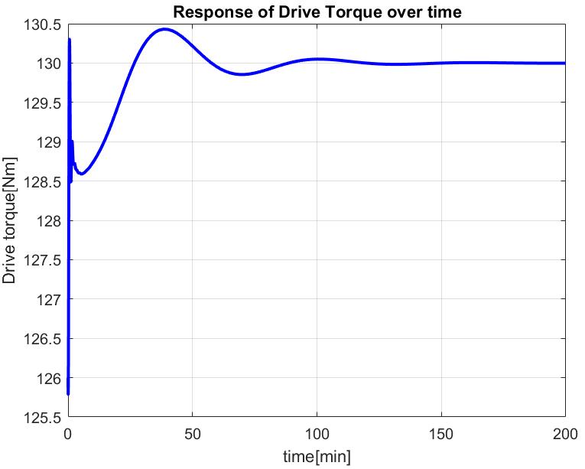

**Figure 3.** Response of drive torque with step increase of 4 Nm controller designed (, initial simulation)

Based on the work from Part 1 question 1, we first designed the controller to have parameters , and plotted the system as shown in **Figure 2** and **Figure 3.** We want to get the Drive Torque to 130 Nm as quickly as possible and keep Die pressure as close to 210 psig as possible. From **Figure 2**, we can see that the fluctuation range of Die pressure response is from 170 psig to 222psig. From **Figure 3,** it is observed that the response of Drive torque reaches steady state at about 125 min. To reduce the fluctuation of Die pressure and time taken to reach steady state for Drive Torque response, we tried tuning the parameter to , it does reduced the time taken for Drive torques response to reach steady state and the fluctuation range of Die pressure is also reduced but still quite big, so we decreases and by 1 unit, and we get about the same time to reach steady state for Drive torque response and a smaller fluctuation range. Thus, we eventually tuned the controller parameter to , which gives and , and plotted as shown in **Figure 5** and **Figure 6.**

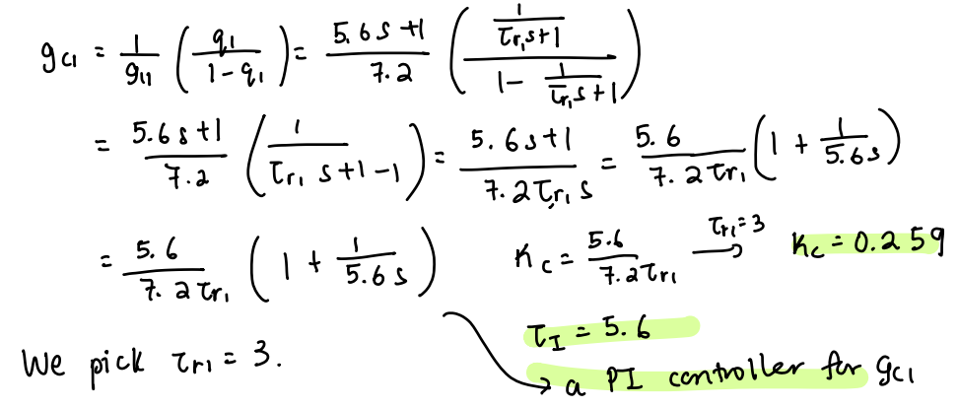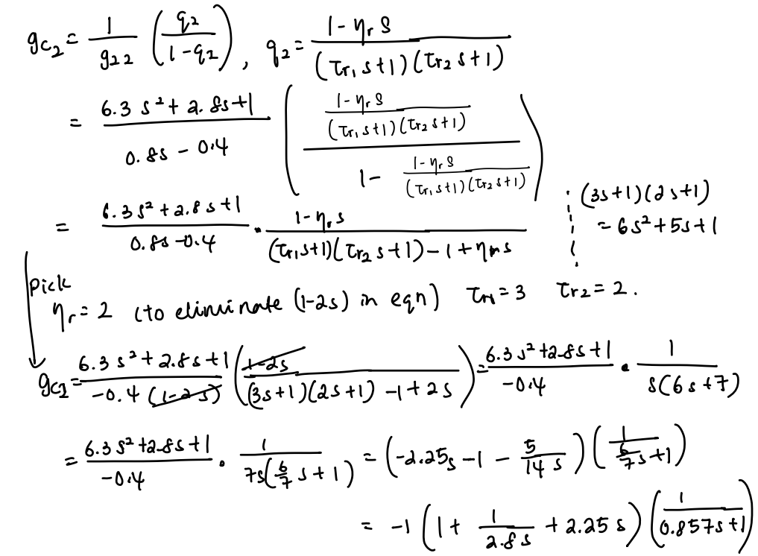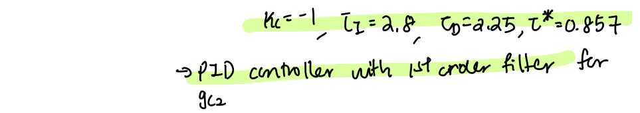

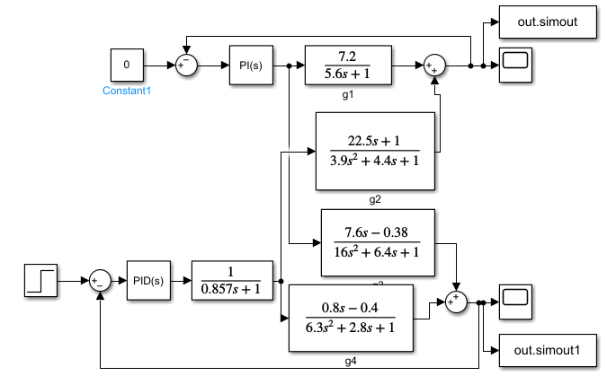

**Figure 4.** SIMULINK setup for Pilot Scale Twin-screw Extruder (, final simulation).

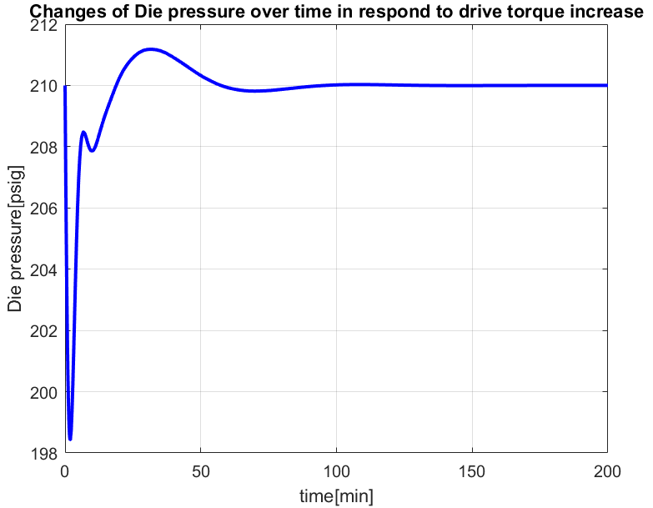

**Figure 5.** Response of Die pressure to increase in Drive torque with controller with tuned parameters (, final simulation).

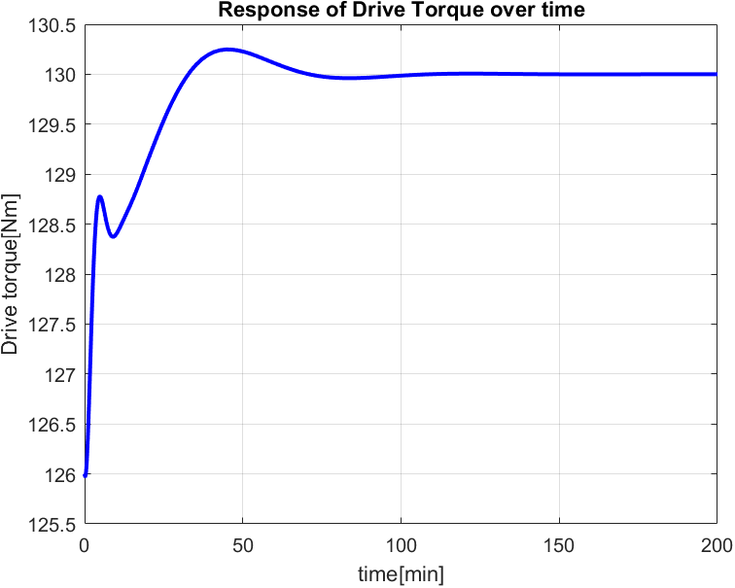

**Figure 6.** Response of Drive torque with step increase of 4 Nm controller with tuned parameters

(, final simulation).

From **Figure 5,**  it is observed that the fluctuation range of Die pressure is smaller (between 198.5psig to 211 psig), compared to that of **Figure 2.** From **Figure 6,** it can be seen that the steady state of response of Drive torque reaches at about 75 min, which is shorter than that observed in **Figure 3.** With the response of Die pressure and Drive torque observed, we decided to set

1. **Effect of Plant/Model Mismatch**

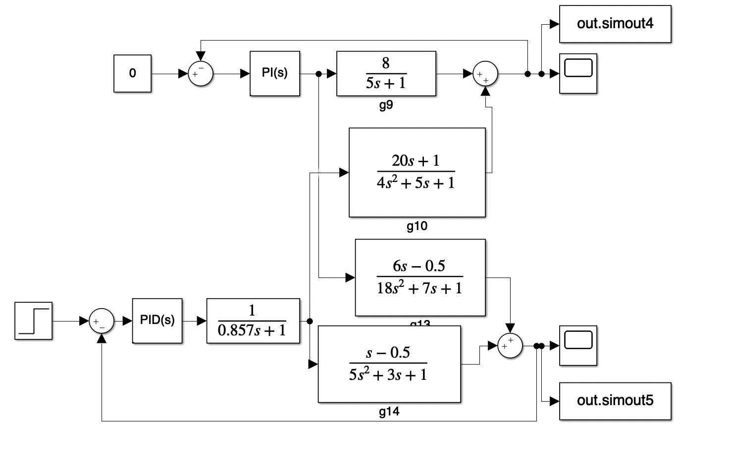

**Figure 7.** SIMULINK setup for Pilot Scale Twin-screw Extruder () with new transfer functions, controller designed in Part 1 question 3 (initial simulation).

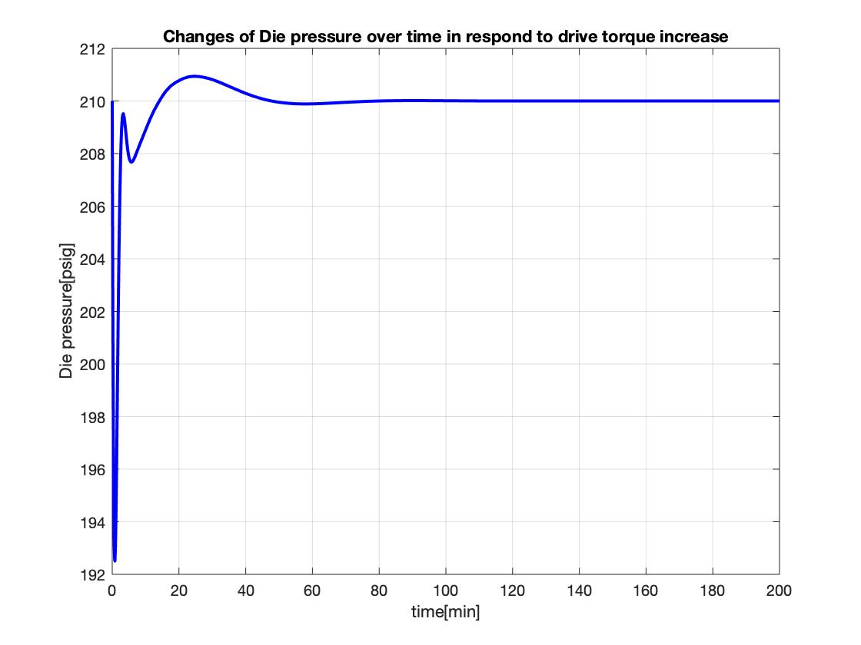

**Figure 8**. Response of Die pressure to increase in drive torque with controller designed in Part 1 question 3 (, initial simulation).

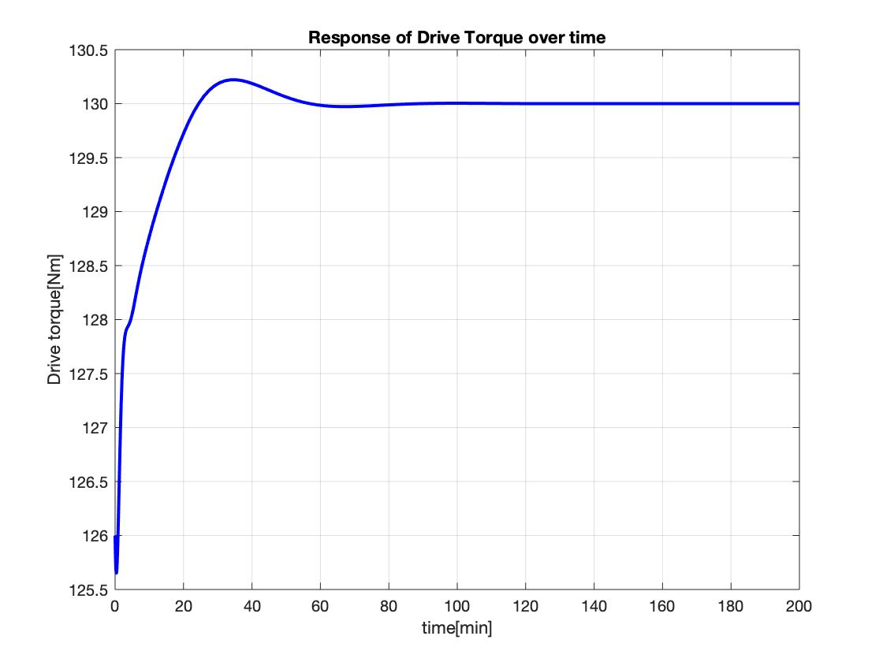

**Figure 9.** Response of drive torque with step increase of 4 Nm controller designed in Part 1 question 3

(, initial simulation).

From **Figure 8**, the fluctuation is bigger than the tuning of the controller in **Figure 5**. The time to reach steady state in **Figure 9** is slightly greater than what was observed in **Figure 6**. Changing the transfer function of the systems affects the fluctuation in die pressure around 210 psig and the time to reach steady state at 120 Nm for the drive torque. Thus, the tuning of the controller is necessary.

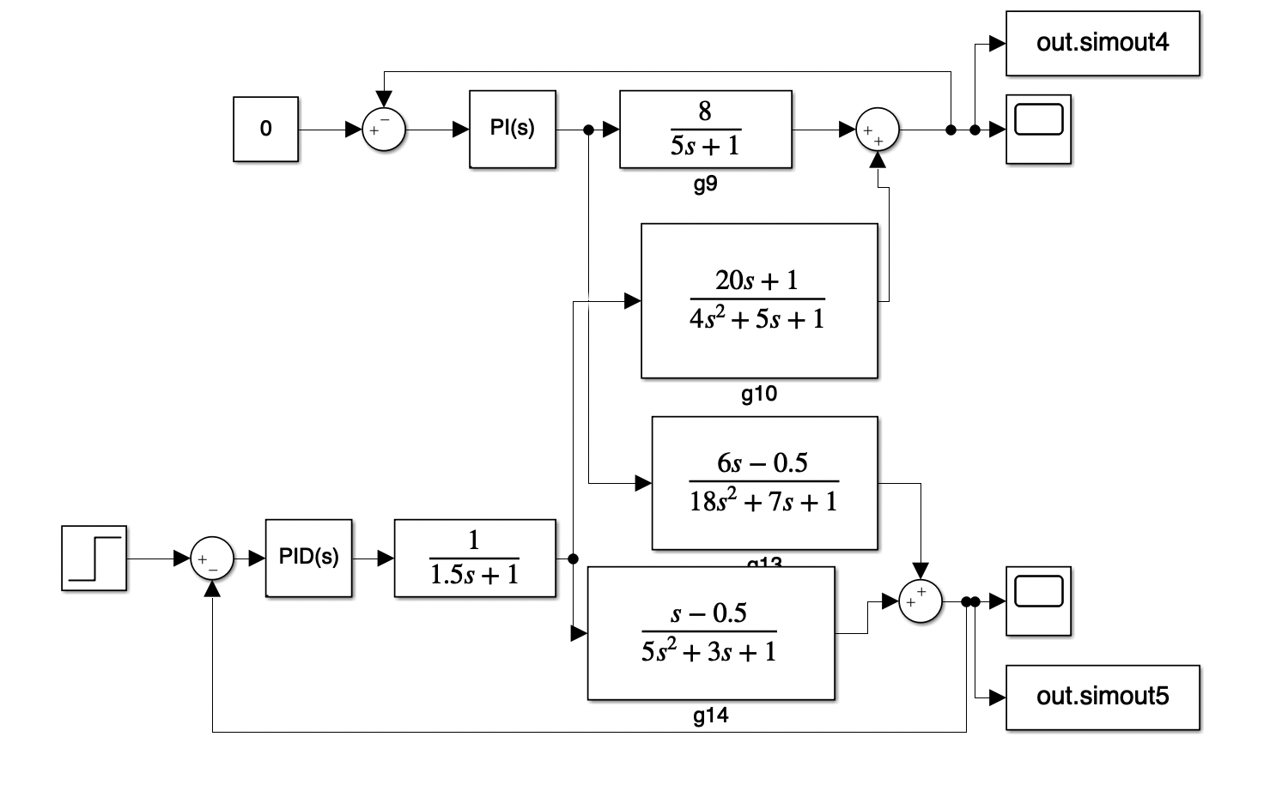

**Figure 10.** SIMULINK setup for Pilot Scale Twin-screw Extruder () with new transfer functions, controller designed in Part 1 question 3 (final simulation)

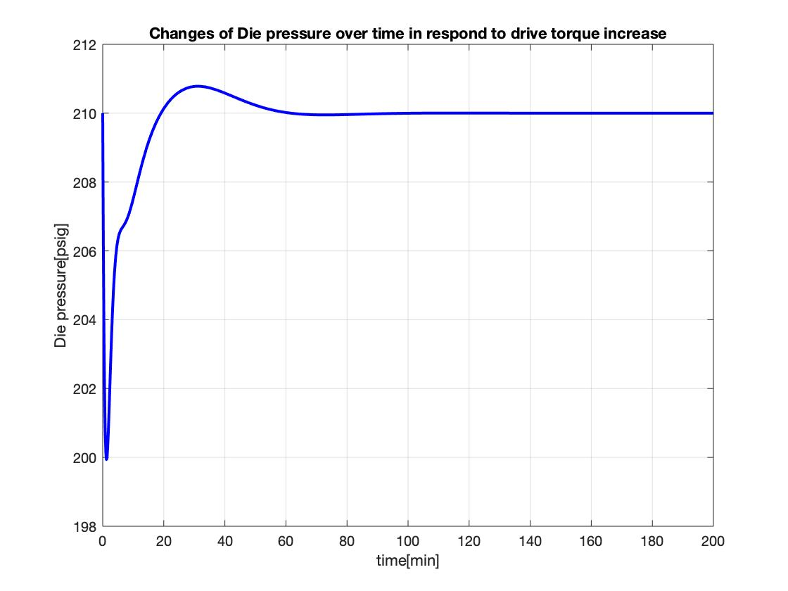

**Figure 11**. Response of Die pressure to increase in drive torque with controller designed in Part 1 question 3 (, final simulation).

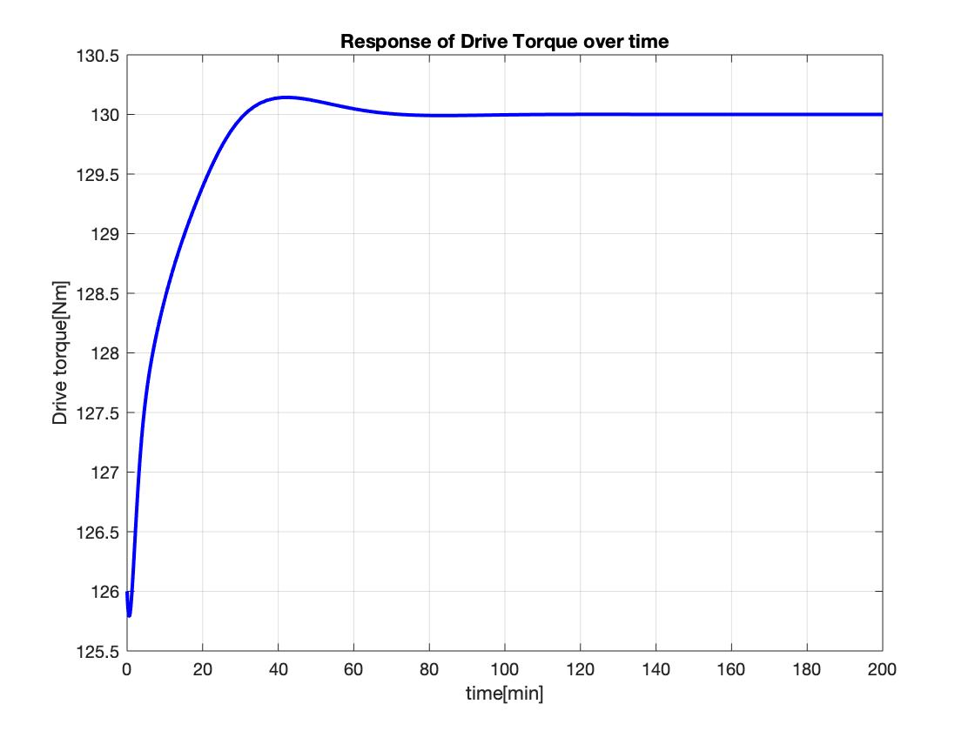

**Figure 12.** Response of drive torque with step increase of 4 Nm controller designed in Part 1 question 3

(, final simulation).

After tuning the controller from to , it could be seen from **Figure 11** that the fluctuation is slightly smaller (minimum of 200 psig) as opposed to the fluctuation observed in **Figure 8** (minimum of 192 psig). At the same time, it also has a smaller fluctuation that the after-tuned controller in part 2 (**Figure 5**). For the drive torque, tuning the controller has only a slight change in the time to reach steady state (**Figure 12** compared to **Figure 9** and **6**). The changes are negligible in comparison to the non-tuned controller in part 3 and the tuned-controlled in part 2.

By looking as a whole, the controller after tuning to with the new transfer functions in part 3 works better than what was proposed in part 2, even after controller tuning in part 2.

**5.2 Part II: Control of a Patient’s Mean Arterial Pressure During Surgery**

1. **Analytical unit step response**

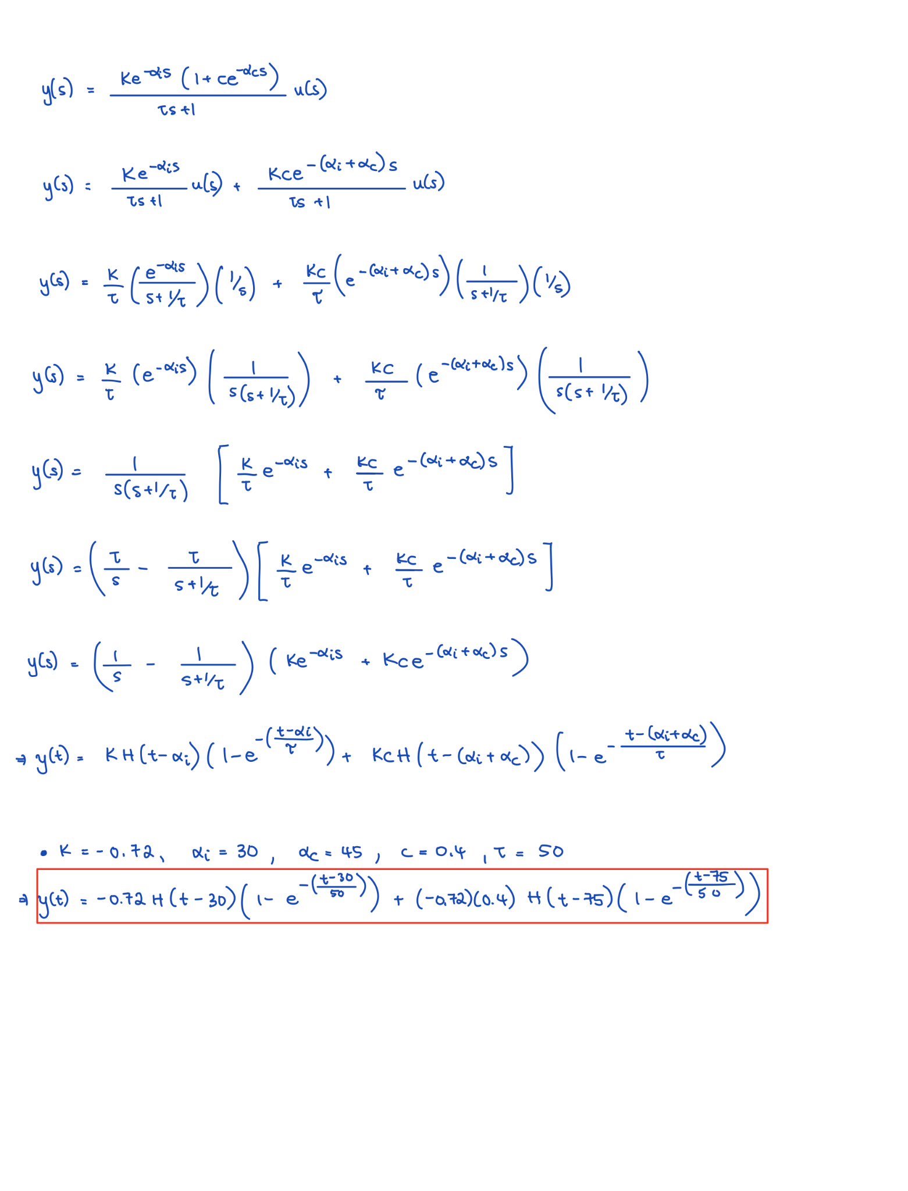

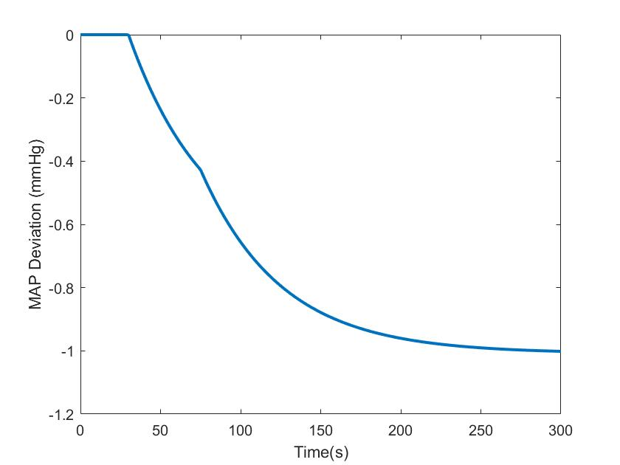

**Figure 13**. MAP Deviation

There is no overshoot, and there are no oscillations. The steady state value of -1 mmHg (MAP deviation) is reached after approximately 250 secs. There is time delay behavior at t = 30 seconds and t = 75 seconds.

1. **Classical controller design**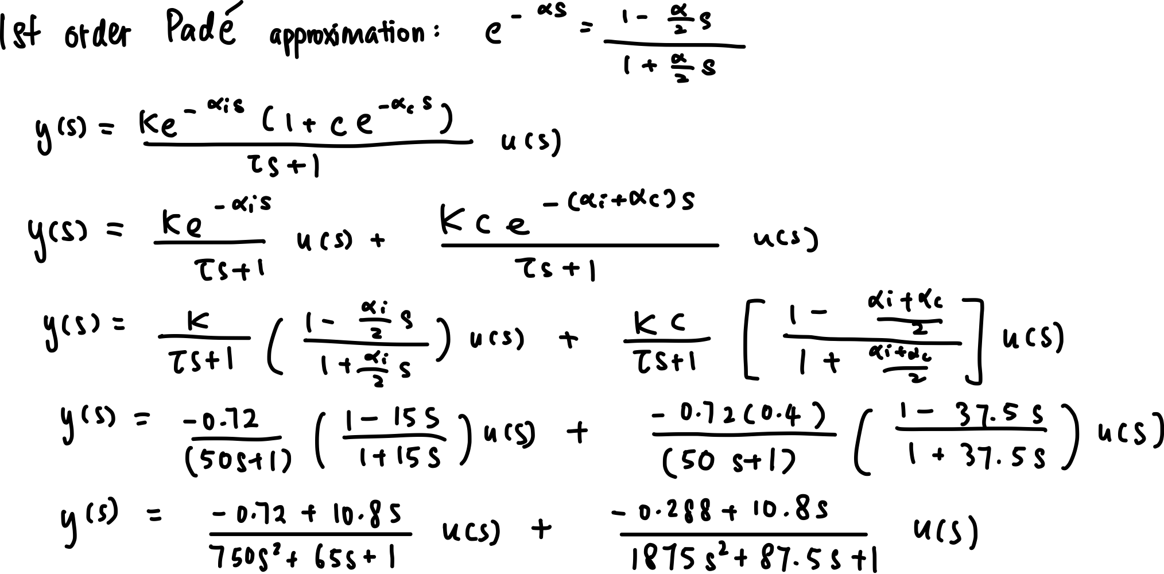

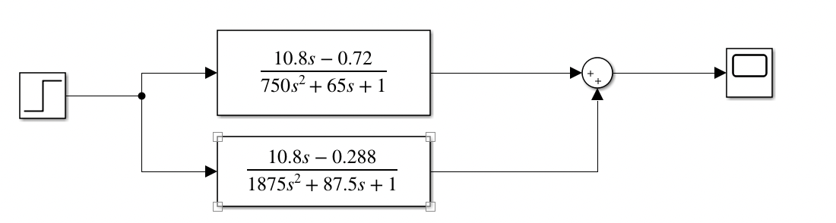

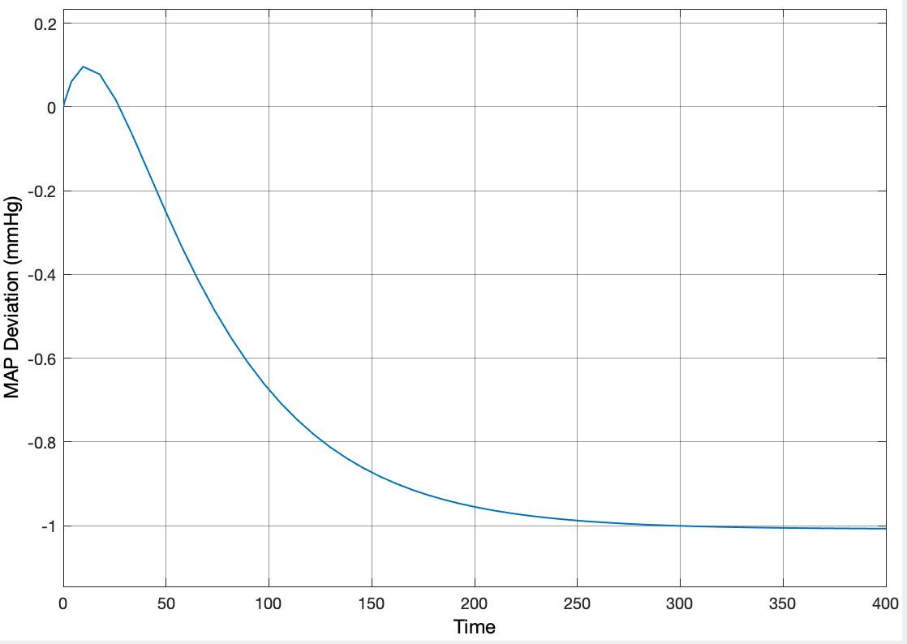

**Figure 14.** SIMULINK setup (top) and plot (bottom) for response of 1st order Pade approximation.

From **Figure 14**, we can obtain K, values. K is -1.007, is around 26.

FOTPD approximation:

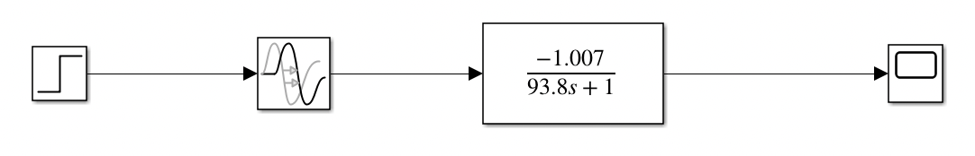

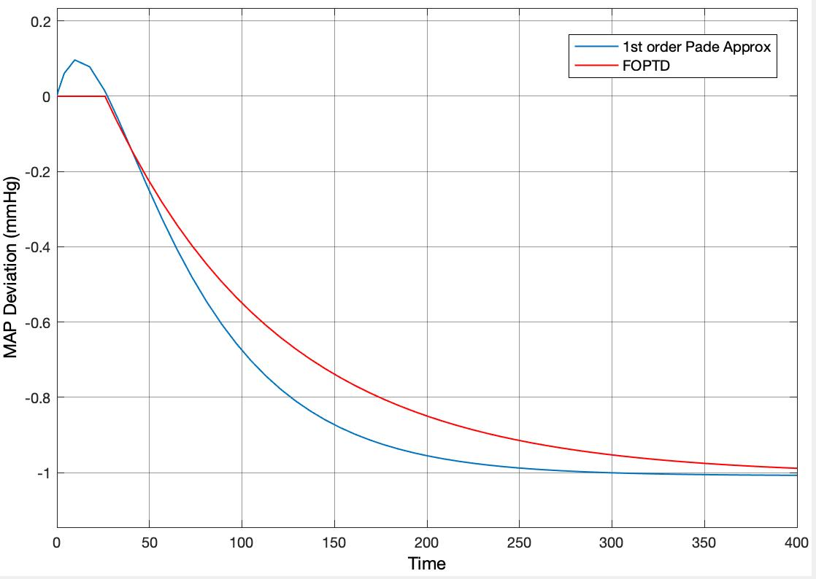

**Figure 15.** SIMULINK setup and plot for response of 1st order Pade approximation and FOPTD.

From FOPTD, use Zieger-Nichols tuning rule to obtain these parameters for the PID controller:

Kc = 1.2/K(τ/α)=1.2/(-1.007)(93.8/26)= -4.299

𝜏I = 2.0𝛼 = 2.0 (26) = 52.0

𝜏D = 0.5𝛼 = 0.5 (26) = 13.0

1. **Model-based controller design**

Using Smith predictor, assume no model errors, gm(s) = g(s) and **,**

Parameters for PI controller:

1. **SIMULINK implementation I**

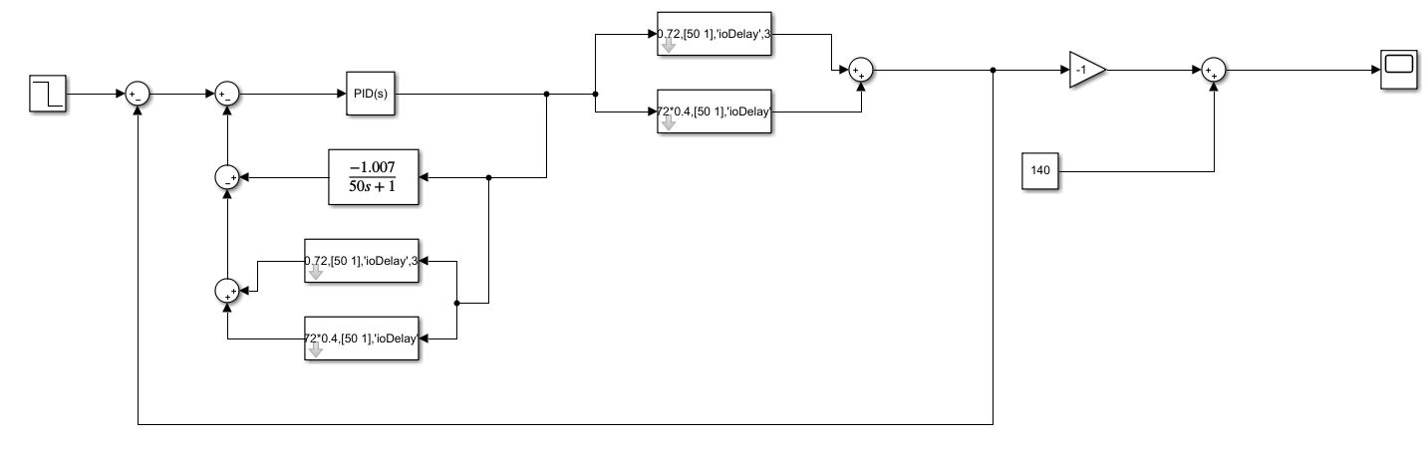

**Figure 16.** SIMULINK’s block diagram for PID controller

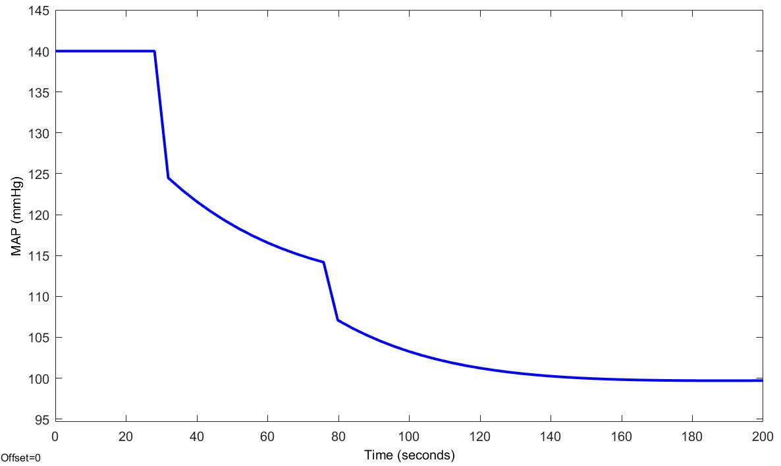

**Figure 17.** MAP (mmHg) using PID controller

The PID controller allows the system to achieve the objective of starting out at 140 mmHg and maintaining at 100 mmHg. There are no points in the graph that show response below 90 mmHg.

1. **SIMULINK implementation II**

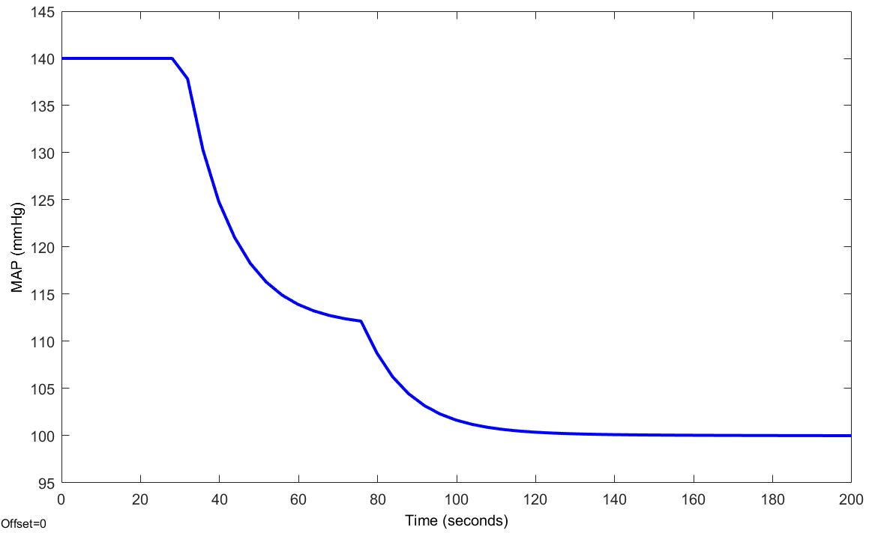

**Figure 18.** MAP (mmHg) using model-based controller

For the model-based controller, MAP reaches steady state at around the 120-second mark and the steady state value is 100 mmHg.

For the PID controller, MAP reaches steady state at around the 150-second mark and the steady state value is 100 mmHg.

→ Model-based controller reaches steady state much faster than the PID’s controller.

1. **Commentary**

If I was an anesthesiologist, I would consider using automatic control technology in practice as it is easy to implement and provide accurate results. From the graphs above, the controller works well, the responses do not show any sign of ill-behavior and the MAP does not drop below 90 mmHg.